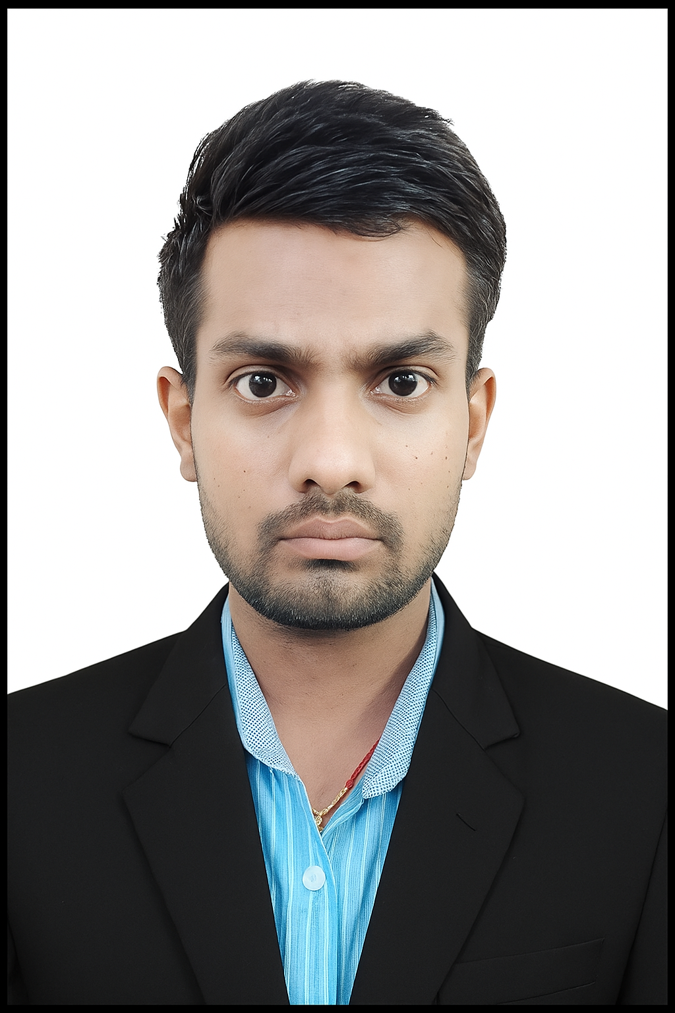 | RAJAK DEEPU KUMAR | ☎: 9409256277; 8980556155
 | DOB: 21 December 2003 | Email: rajakdeepu321@gmail.com
 | Father: Madan Kr. Rajak | Language: English, Hindi, Gujarati
 | Mother: Premshila Kumari | GitHub: Deepu-Research-Unify
 | Address: Ankleshwar, Gujarat, India | LinkedIn: rajak-deepu-kumar

PROFESSIONAL SUMMARY
A research-driven Environmental Science scholar with a strong academic background in sustainability, renewable energy technologies, and interdisciplinary education. Holds a Bachelor of Science with a dissertation on sustainable education models, and a Master of Science focusing on innovative renewable energy solutions for climate change mitigation in rural Bihar.
Experienced in environmental sampling, pollution monitoring, Remote Sensing, GIS, Data analysis, policy-based research and Auditing. Demonstrated leadership in academic coordination, innovation council activities. Actively applied engaged in capacity-building initiatives, sustainability workshops, and collaborative research in green future platforms.

CAREER OBJECTIVES
Seeking a role as an Environmental Officer to contribute to sustainable development and public health through scientific environmental management. To integrate my scientific research which engagement to drive climate resilience and sustainable development through collaboration.

EDUCATION

PROGRAM | DISCIPLINE | AFFILIATION / BOARD | YEAR | RESULT
M.Sc. | Environmental Science | Central University of South Bihar, Gaya Ji | 2025 | Distinction
B.Sc. (Hons.) | Environmental Science | The MS University of Baroda, Gujarat | 2023 | 1st Class
Intermediate | PCM | JNV, Roopnagar, Bharuch, Gujarat - CBSE | 2020 | 1st Class
Matriculation | Equivalent | JNV, Roopnagar, Bharuch, Gujarat - CBSE | 2018 | Distinction
CCC | ICT Concepts | Infosoft Pvt. Ltd., Gujarat – Govt. of India | 2017 | Distinction

CERTIFICATION
- Course on Computer Concepts (MoCA, Govt. of India) | - IoT Software Analyst (Reliance Foundation)
- Solid Waste Management (SWAYAM) | - Sustainability and Corporate ESG (Reliance Foundation)
- Non- Government Organization (SWAYAM) | - Professional Career Edge (TCS)
- Data Analytics and Auditing (Deloitte and KPMG) | - Environmental Health and Safety (UniAthena)

DISSERTATION
- Working toward the Sustainable transformation of Education linked with Tech-Trad Methods May 2023
Supervisor: Dr. Swayam Siddha (BS - Environmental Science)
- To enrich curiosity with the pedagogy technique demand from the Pupil in a sustainable environment

- Innovative Renewable Technologies and their Role in Climate Change Mitigation of Rural Areas in Bihar May 2025
Supervisor: Prof. Pradhan Parth Sarthi and Dr. Sunny Kumar (MS - Environmental Science)
- Exploring and Assessing the Currents Energy Trend to developing sustainable manner of energy production in Bihar

EXPERIENCE
DESIGNATION | ROLE | YEAR
National Service Scheme (NSS) | Volunteer for Workshops and Program | March 2025 – Present (Remote)
Showcase: Ideation (IIC - CUSB) | Event Treasurer and Coordinator | Jan 2025 - Feb 2025
Institution Innovation Council - CUSB | - Executive Joint Secretary  - Department Co-ordinator  - Innovation Joint Secretary | Sep 2024 – July 2025
Environmental Awareness Programme | Adviser, Report Analyst | Jan 2024 - June 2024
Swachh Bharat Internship | Group Leader, Report Analyst | Oct 2023 - Dec 2023
Sattva – The Enfest | Organization Committee | Feb 2023
प्रकृति प्रहरी – पर्यावरण संरक्षण | Volunteer for Awareness | April 2022

CORE COMPETENCIES
Discipline | Atmospheric Science, Earth Science, Ecology & Restoration, EIA & Auditing, LCA, EMS and Legislation, Parameter Sampling & Testing, Waste Management, Disaster Risk Assessment, Urban Planning, Remote sensing, Bio-statistics, Eco-toxicology, Occupational Hazards and Safety
Technical Skills | Instrumentation and Monitoring, Data Analyst, GIS Mapping, R-Software, Basic Coding, MS Office, Research Methodology, Data collaboration, Analysis, Management, Documentation, Presentation
Soft Skills | Teamwork, Leadership, Critical Thinking, Problem Solving
Interest | Gardening, Mentoring, Curiosity on IKS, Sustainability startup, Workshops, Seminars, AI prompting

POSITIONS AND RESPONSIBILITY
- Innovation Joint Secretory Institution’s Innovation Council (IIC) – CUSB Jan 2025 - July 2025
- Department Co-ordinator Institution’s Innovation Council (IIC) – CUSB Sep 2024 - July 2025
- Executive Joint Secretory Institution’s Innovation Council (IIC) – CUSB Sep 2024 - July 2025
- Class Representative Department of Environmental Science Oct 2023 - May 2025
- Group Leader (NCSC) JNV: National Children Science Congress Nov 2015 - Dec 2017
- Academic Counsellor Career guidance to youngster Dec 2013 – Present*

ACHIEVEMENTS
- Showcase: Ideation (IIC - CUSB): Event Treasurer & Coordinator 2025
- Environmental Intern: To assess the Environmental Impact reliable with health and pollution 2024
- Swachh Bharat Internship: (Fieldwork) 2023
- Deepu’s Research Unify: Blogging Website 2023
- Agastya Foundation: Conducted workshops using scientific experimental learning methods 2023
- IIT-JAM (Economics): Qualified 2023
- Earth ka अर्थ: Conducted Webinar on the occasion of an Environment Day;(Batch: BS: EVS-FY) 2020
- KVPY: Qualified 2019
- National Mathematics Olympiad (NVS): First Position with Cash Prize 2016

PERSONAL DETAIL
Name | : | Rajak Deepu Kumar
Date of Birth | : | 21st December 2003 | Blood Group | : | O ^{+ve}
Key skills | : | Mentor, Sustainability Education, Instrumentation, Data and Report Analyst, Leadership.
Address (C) | : | H/N – 153, Krishna Park society, near Kapodara Patiya, Valia Road, GIDC, PO: Bhadkodra, Ankleshwar, Dist.: Bharuch, Gujarat; Pin code: 393001
Address (P) | : | Ward Number: 14, Village: Turkaulia, Post: Kamalpura, PS: Paroo, Bhaya-Bakhra, Saraiya Road,  Dist.: Muzaffarpur, Bihar, Pin code - 843101

DECLARATION

I hereby declare that the information provided above is true and correct to the best of my knowledge and belief.

Place: Ankleshwar

Rajak Deepu Kumar

